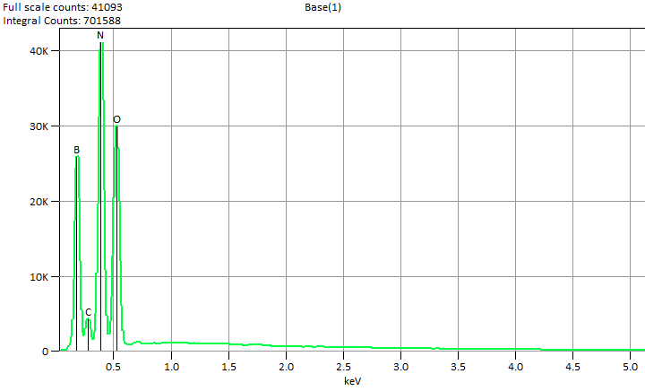

Live Time: 60.0 sec.

Fri Nov 22 16:00:41 2024

Filter Fit Chi Squared:203.293

Errors: +/- 1 Sigma

Correction Method: Proza (Phi-Rho-Z)

Acc.Voltage: 5.0 kV Take Off Angle: 35.1 deg.

Detector: UltraDry

WDS Results Unavailable for: Base(1)

|  |
| --- |
|  |

Quantitative Results for: Base(1)

|  |  |  |  |  |  |  |
| --- | --- | --- | --- | --- | --- | --- |
| ***Element***  ***Line*** | ***Int.***  ***Cps/nA*** | ***Int.***  ***Error*** | ***Weight %*** | ***Weight %***  ***Error*** | ***Atom %*** | ***Atom %***  ***Error*** |
| ***B K*** | 2171.5 | ± 22.77 | 15.6 | ± 0.2 | 20.2 | ± 0.2 |
| ***C K*** | 276.13 | ± 26.52 | 1.4 | ± 0.1 | 1.7 | ± 0.2 |
| ***N K*** | 3573.4 | ± 20.75 | 41.2 | ± 0.2 | 41.3 | ± 0.2 |
| ***O K*** | 3095.4 | ± 19.58 | 41.8 | ± 0.3 | 36.7 | ± 0.2 |
| ***Total*** |  |  | 100.0 |  | 100.0 |  |

ROI Results for: Base(1)

|  |  |  |
| --- | --- | --- |
| ***Operation*** | ***Gross Counts*** | ***Net Counts*** |

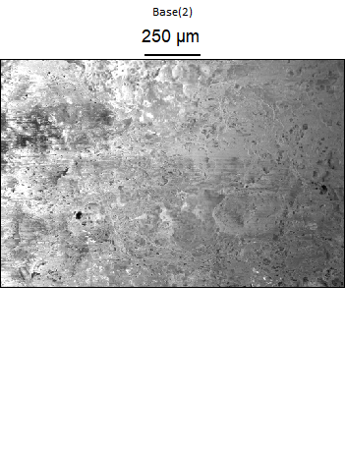

Data Type: Counts

Image Resolution: 512 by 340

Image Pixel Size: 2.97 µm

Map Resolution: 128 by 84

Map Pixel Size: 11.89 µm

Acc. Voltage: 5.0 kV

Magnification: 140

